Do Parrots Need A Bed?
I have seen many avian pet owners get concerned over their birds’ diet, toys, and cage. And as from a first time Caiques/Conure owner, I used to be all worried about these factors contributing to my pet’s well-being. We have done lots of research on their basic natural requirements and instinctual needs, over the years..
But over the years, I have realized that often many bird-owners forgot about the need for a bed for their parrots. Or believe a lot of the myths they have seen or read on Facebook or Google sadly lots of these actually have no more or even less experience than the people asking for advice.. However, sleep being an integral and vital part of ensuring your parrot’s health, the importance of beds needs to be considered.
So, do Caiques/Conures need a bed? Yes, Caiques/Conures need a bed to sleep well and better inside the cages. However, the needs and the personalities of each parrot being different from the other, a bed is not necessary for every parrot; but those who prefer the comfy feeling and suffer from night frights definitely need one.
Conures and Caiques and some others are not perch sleepers they are naturally hollow Crevice sleepers :) Some may sleep on the tummies, backs and sides etc. But hard to do that from a perch or hanging off the side of the cage as we have seen as they are either scared to sleep elsewhere as cannot find a safe cavity to sleep in that they feel secure in. Just for the record we have 100’s of conures and quite a few Caiques as well, Inside birds as well as outside birds and there is not one that chose to sleep on the perch instead of a box
Parrots are great social birds to be around. And believe it or not, but Caiques/Conures like to feel comfy and snuggle. And while you focus on setting up the cage for your avian friends with toys and perches, forgetting about its bedding is never suggested.
From my experience of many years with our many different parrots like Conure Caiques Etc. I can say for sure that giving them beds to sleep boost their sleeping experience inside the cage as well as out in an aviary.
Whether it’s a baby parrot or a large one, your Caiques/Conures will be looking for a bed to sleep and play. So, let’s find out about why parrots need a bed, why they find a bed good and where you can find good beds for your birds.

Reasons why parrots need beds
Parrots are known to be extremely intelligent, highly social and tremendously curious birds. Having such lively and talkative birds around can liven up the atmosphere of any household.
While parrots love to move around and stay active, they also require a good night’s sleep. To ensure that your parrots receive the needed amount of sleep, installing comfortable beds in the form of nest or cave or sleeping box is a great idea.
Here is why parrots need and enjoy having a bed inside their cages:
- Owning a bird is a big responsibility along with ensuring its well-being. Hence to make sure your parrots get good sleep (which they need to stay healthy), they need beds
- A bed serves as a perfect place for your parrots to rest
- A bed offers a parrot a sense of comfort and security and privacy
- Box offer your parrots a place to retreat when they are looking for seclusion during the day (something the open end tubes huts and tents cannot offer)
- Bird beds imitating nest cavities, they also help your parrots feel more secure and calmer while in cages or new environments.
- Hens need a sleeping box for warmth & humidity to prevent hypothermia (from not having a box to sleep in), environmental stress have all been implicated as causes of egg binding.
- In bed caves & sleeping boxes, they can enjoy complete darkness at night which they need to sleep well, as with the light changing as days get shorter it stimulates the release of their breeding sex hormones that give parrots the urge to breed.
- Give them warmth in winter and keeps them cool in summer, artificial heating that you see caregivers offering only confuses the bird and stimulates their release of their breeding sex hormones that give parrots the urge to breed also.
- Wooden boxes are safe, secure and protective, As wood is a digestive material that they chew in the wild they can also chew it safely in captivity, Unlike anything made from fabric type materials like cotton, Synthetic threads, felt, canvas, seagrass and matting etc.

What makes a good bed for parrots?
Nowadays, there are various types of beds available for parrots. But, as far as good beds are concerned it is recommended to opt for beds that are made with quality wood type materials which pose no health threats to the parrots.
Since, parrots like to chew on almost everything; beds made with good safe wooden products should be high on the priority list of any parrot owner.
Remember, if a bird can sleep comfortably, it offers a sense of security and helps it to become more used to the present house and the owner.
A good bed for your parrots is always the one that offers them with the needed support, comfort and security while sleeping. If the materials aren’t soft or comfortable enough for your parrots, your birds may not like to go to it to rest let alone sleeping in the bed/box. We recommend having at least 100mm of untreated pine shavings in the bottom of the box.
Depending on the size your parrots, make sure the box you buy for them is spacious enough, as parrots often like to play in the beds and later sleep in them.
While opting for hanging sleeping/nests boxes make sure to get necessary hooks and clips to offer a safe and properly hung box for your parrots.
Along with comfort, a good bed for parrots should offer the birds with needed warmth during the cold weather. Durability, lightweight and soft, portability and easy to fix are some of the qualities to be present in a good bed for your parrots.
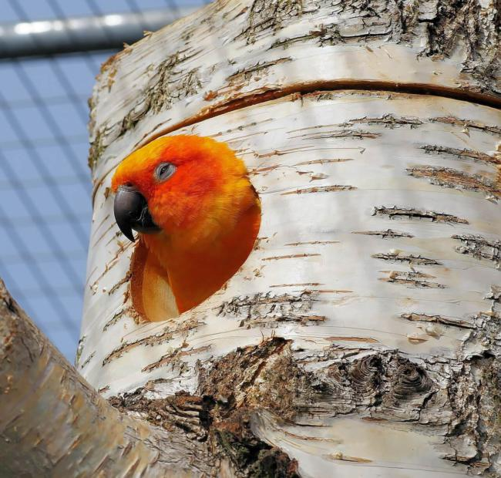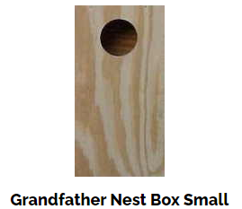
Interior dimensions are 25 x 25 x 40cm tall. Entrance hole is 75mm

Finding a good bed for your parrots
Boxes & logs for birds can be found in pet stores and retail stores. However, buying them online can save both your precious time and money. But make sure there a good quality 16 -18mm ply or timber as they will chew through flimsy soft type ones in no time at all putting wooden block in side to chew is also a good idea
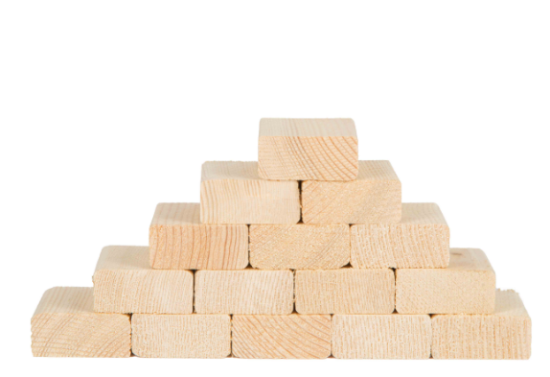

Yes, there are many reputed and reliable websites but below as one that Amazon sells cheap and nasty that will only last a few days sadly
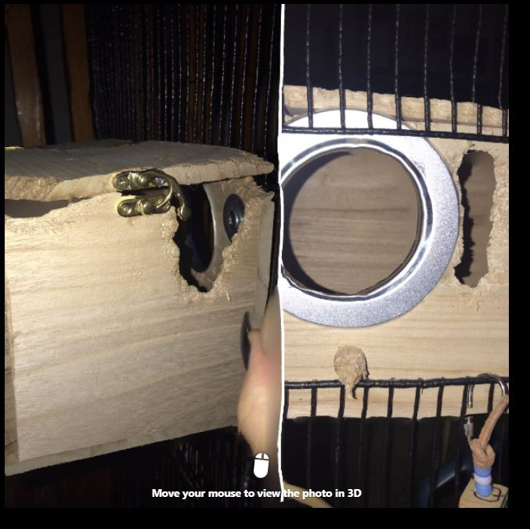
Here are some good bed options to stay well away from as they are deadly death traps for your pet bird from crop impaction and usually death or entanglement

Hanging Swing Hammock Dangerous
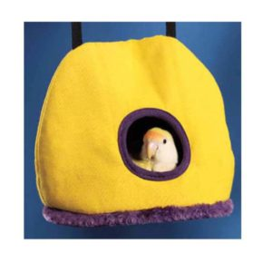

Hanging Snuggle Cave/happy huts Dangerous

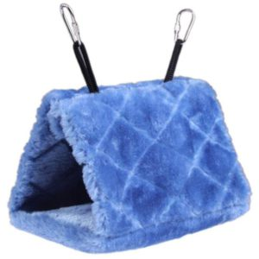

Bird Nest House Bed Dangerous
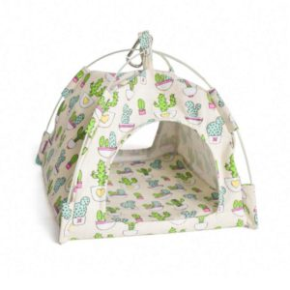

Related Information
What to keep in mind when making DIY beds for parrots? When planning to make a DIY box for your parrots, make sure to use safe and non-toxic materials as well as inside the box bed. Before putting the bed for use, fasten it properly to the bars of the cage for safety. Also hang it as high as possible in the cage or Aviary so as they feel secure, you may have to pop them into their new box for a few nights while its dark so they know it’s safe and ok as the can take a little while to get accustom to new things
Do parrots sleep during the night? Yes, parrots do sleep at night. Sleep being crucial to every bird’s well-being, a parrot needs around 8 to 10 or 12 hours of sleep every night to stay healthy and happy. Due to the way nature has designed them, parrots follow the sleeping schedule of waking up at sunrise and sleeping after sunset. The changes in the length of the day and also the temperature change is what tells them what season it is.
“In nature, these are the seasonal changes that create conditions that stimulate the release of breeding sex hormones that give parrots the urge to breed” Written by Dr Marshall, Avian veterinarian & nutritionist with an M.A.C.V.Sc. Degree in Avian Medicine
Can parrots sleep with the lights on? Distractions like light or noise prevent a parrot from falling asleep at night. Since a bird’s instinct is to stay awake as long as there is light and activity, parrots fail to sleep with lights on. Turning off the lights and covering the cage with covers help parrots to have undisturbed sleep.

